Objective:
Project report
Vrinda Store wants to create an annual sales report for 2022 so that Vrinda can understand its customers and increase sales in 2023.
Business Questions to Be Answered:
• Compare sales and orders using a single chart.
• Which month recorded the highest sales and number of orders?
• Who purchased more in 2022: men or women?
• What are the different order statuses in 2022?
• List the top 10 states contributing to total sales.

1 order vs sales :
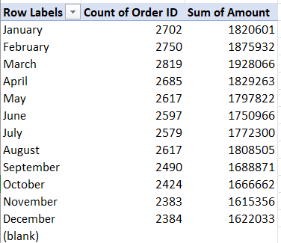

2 Age and gender relationship: 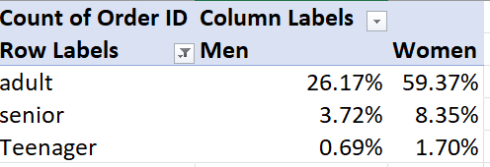
3 Top 10 states :
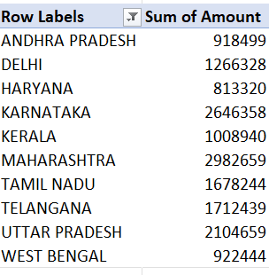
4 Order status :

5 Sales according to gender :
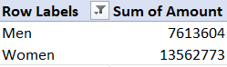

Final Vrinda store report store 2022 dashboard :
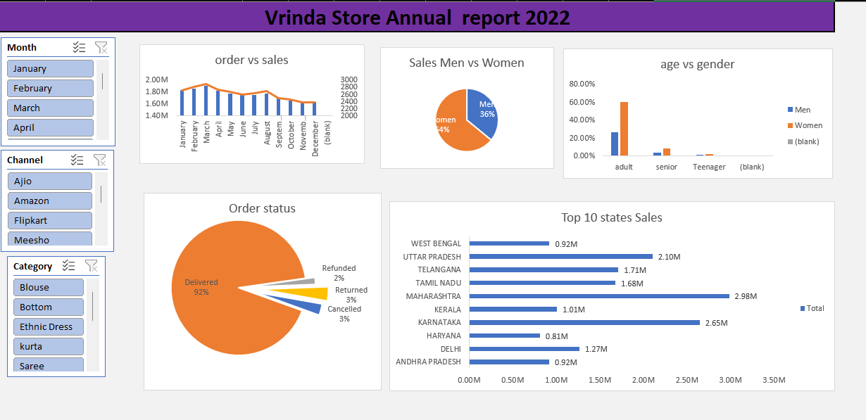

Key Insights / Findings:
• Sales and orders show a similar trend across months, indicating that higher orders directly contribute to higher sales.
• March recorded the highest sales and number of orders in 2022.
• Women customers contributed more to total purchases compared to men in 2022.
• The major order statuses observed were Delivered, Cancelled, Returned, and Refunded, with delivered orders forming the majority.
• The top 10 states contributing to sales include Maharashtra, Karnataka, Uttar Pradesh, Telangana, Tamil Nadu, Delhi, Kerala, West Bengal, Andhra Pradesh, and Haryana.
• Adult customers placed the highest number of orders, with women dominating across most age groups.
• The online sales channel contributed the maximum share of total sales.
• Ethnic wear emerged as the highest-selling product category.

Conclusion:

The analysis of Vrinda Store’s 2022 sales data provided valuable insights into customer behavior and sales performance. The study revealed that sales were highest during the early months of the year, with women customers contributing the majority of purchases. Most orders were successfully delivered, indicating strong operational efficiency. Maharashtra and Karnataka emerged as the top-performing states, while adult customers formed the largest customer segment. Additionally, online channels and ethnic wear categories played a significant role in driving overall sales. These insights can help Vrinda Store make data-driven decisions to improve marketing strategies, optimize inventory, and increase sales growth in 2023.

